September 18, 2022

*Those who are able, please stand.
Prelude Silently prepare your hearts for worship.
Welcome / Announcements
Opening Prayer
Gloria Patri #559 (Red)
Answered Prayers
Call to Worship #281 (Red) “O, How I Love Jesus”
God’s Spoken Word 1 Timothy 2:1-7
Greeting
Lord’s Prayer
*Doxology #554 (Red)
*Hymn #111 (Red) “How Firm a Foundation”
*Worship Song “Cornerstone”
*Worship Song (Insert) “Sanctuary”
Children Dismissed
Sermon Work of Faith
*Worship Song “Do It Again”
*Postlude

If you are a Visitor with us today, Welcome!

Please place your offering(s) in the offering
plate on the table at the back of the sanctuary.
Prayer Concerns:
Keep our students and teachers in your hearts and prayers. They are excited to start a new school year. Lord: help all students and teachers settle back into this new year to learn, grow, and have fun. Amen

Leaders in today’s Service:

Pastor | Ken Andrs
Organist | Peggy Bartelt
Vocalists | Al Judd
 | Tracy Pomeroy
 | Elaina Andrs
Multi-Media | Tim Schroeder
Council Duty (September) | Robert Dickerson

Next Week – September 25

Pastor | Ken Andrs
Vocalists | Al Judd
 | Tracy Pomeroy
 | Sadie Smith
Multi-Media | Keith Johnson
Council Duty (September) | Robert Dickerson

Waseca Food Shelf Building Campaign
As you have hopefully noted, First Congregational Church is supporting the fund drive for building an addition on to the Neighborhood Service Center that will serve as the new, permanent, and more accessible location for the Waseca Area Food Shelf. If you want to be a part of this important community project, here are a few notes on donations made through First Congregational Church:
- If paying by check, make check payable to: First Congregational Church (aka: FCC), but note in the comment line that money should go to the “Food Shelf Building Campaign”. You can combine your regular giving with donation to this Campaign, Just note on outside of your envelop amount to regular giving and amount to go toward this campaign
- If paying in cash and using your church envelop series, again, just note that the enclosed amount should go to the “Food Shelf Campaign”. If paying cash and using regular blank envelope, please note your name, and destination.
Any questions, feel free to contact me: Doug Leet, leetd1948@gmail.com, 507-382-8496, or just visit with me in church.

This Week’s Calendar:

TODAY (9/18)
Worship / Sunday School 10:00 am
Council Meeting 11:00 am

Tuesday (9/20)
Men’s Bible Study 7:00 am
Ladies Bible Study 10:00 am

Wednesday (9/21)
Ministerial Soup Lunch (Christian Assembly) 12:00 pm
Family Bible Study 6:30 pm

Upcoming:

Sunday (9/25)
Worship /Sunday School 10:00 am

Tuesday (9/27)
Men’s Bible Study 7:00 am
Ladies Bible Study 10:00 am

Wednesday (9/28)
Family Bible Study 6:30 pm

Ministerial Soup Lunch, September 21st – 12:00 pm
Come enjoy a warm bowl of soup and some good conversation with friends at Christian Assembly church. Freewill offering accepted.

Family Bible Study, September 21st – 6:30 pm
Join us for a Family Bible Study on Wednesdays. We will take time to learn something new or old from one of our community members and then have a short devotional with table discussion. Snacks and fellowship to follow.

Next Week’s Reading
1 Timothy 6:6-19

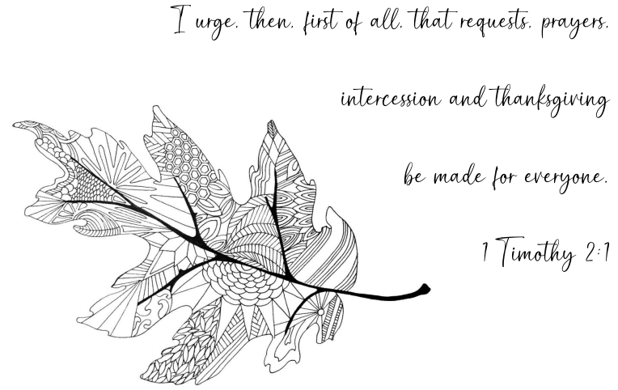

First Congregational Church
503 2nd Avenue NE
Waseca, Minnesota

September 18, 2022

